CAD Renderings of my Housing Case
Ytsa227

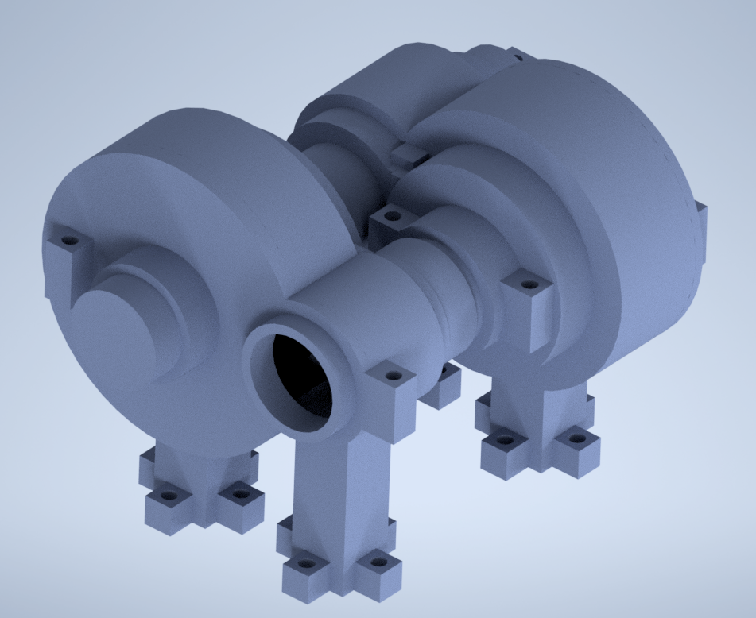
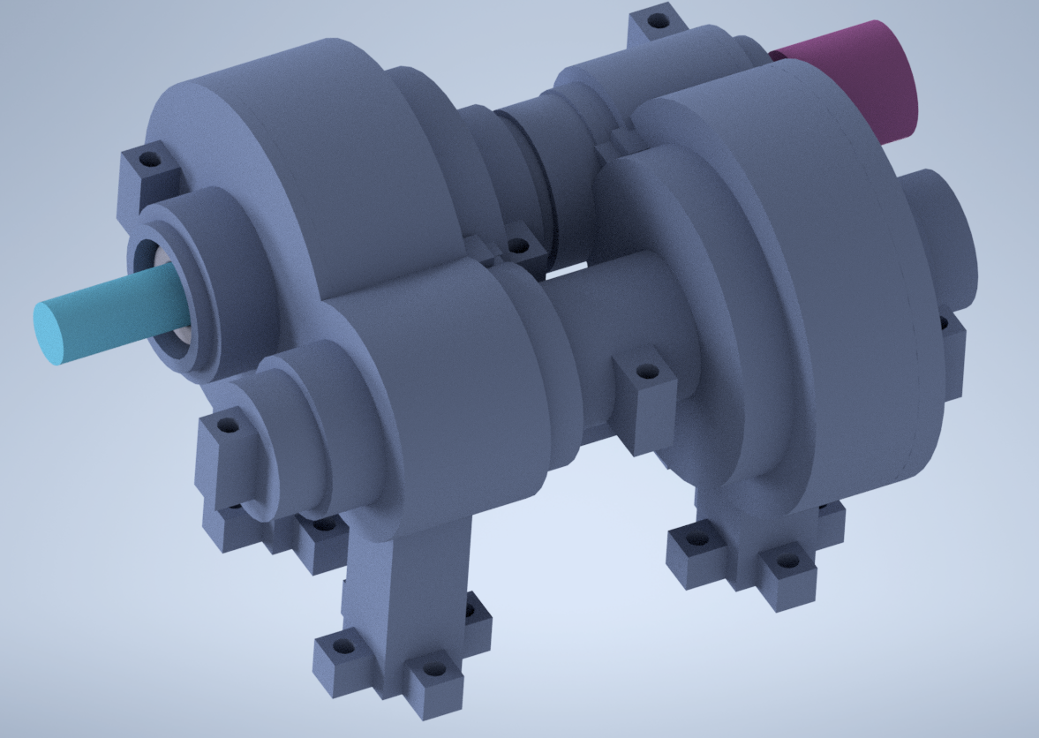

Figure 1: Full Housing Overview with & without Shafts Assembly

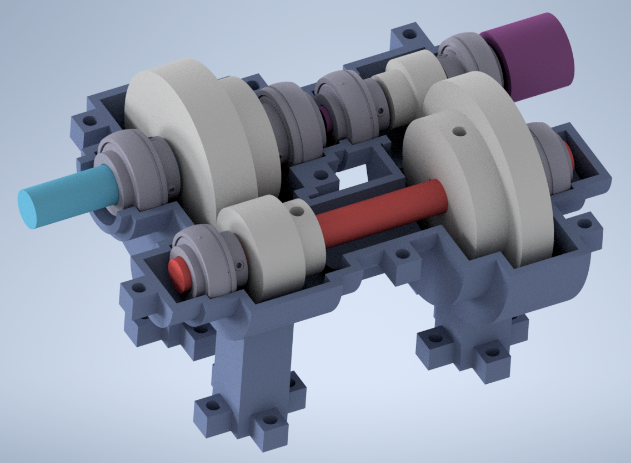
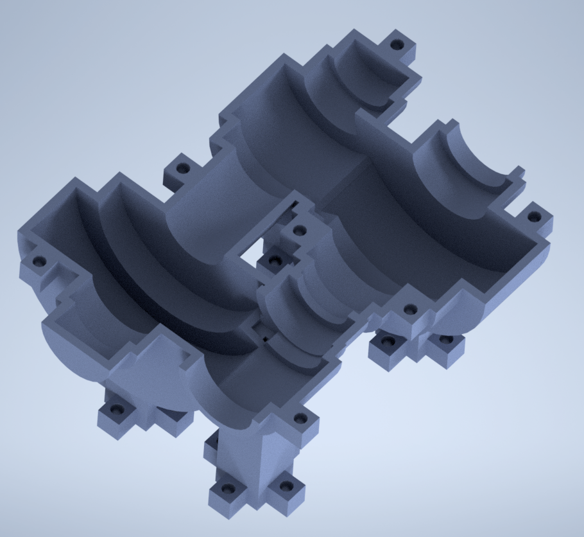
Figure 2: Half Housing Overview with & without Shafts Assembly

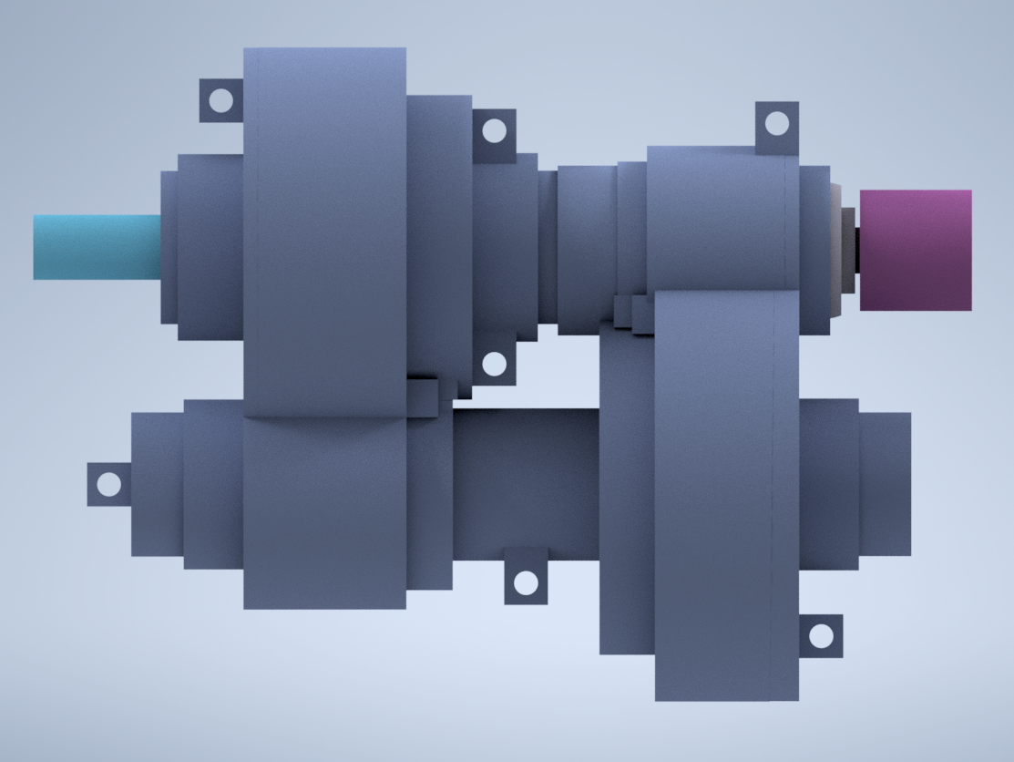
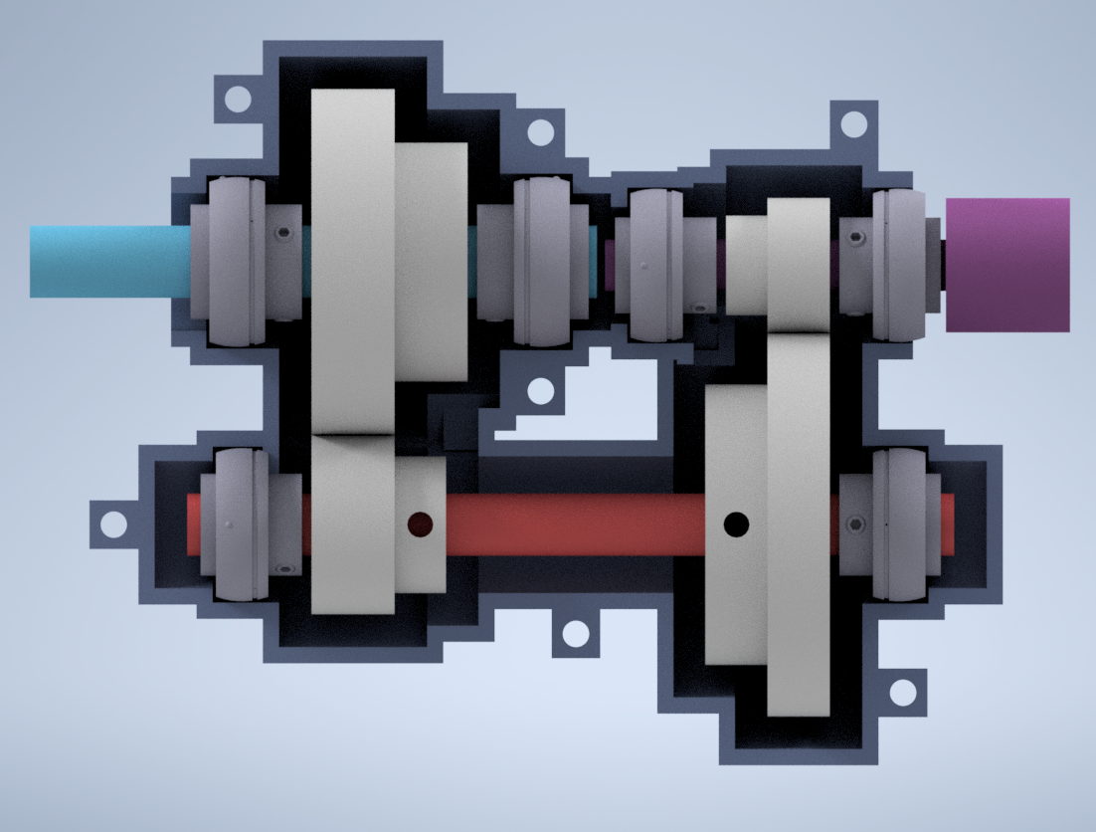
Figure 3: Top view of Housing with Shafts Assembly (the full casing on the left, the half casing on the right)

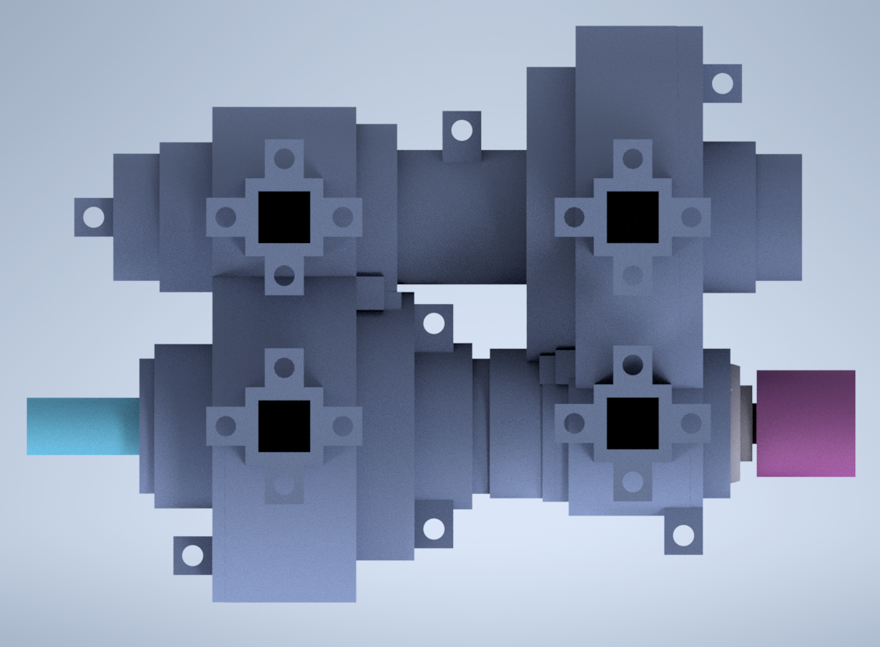
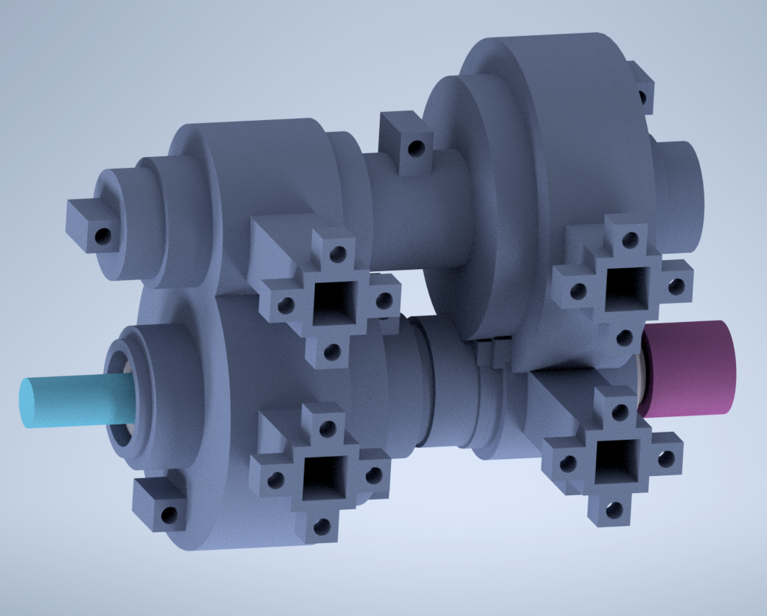

Figure 4: Bottom views of Housing with Shafts Assembly

This Housing Case consists of 2 pieces: Main Bottom Casing Part & Top Casing Part.
The Top Casing Part is just a symmetrically identical part to the Main Bottom Casing Part but without the legs.
Shown below in Figure 5.
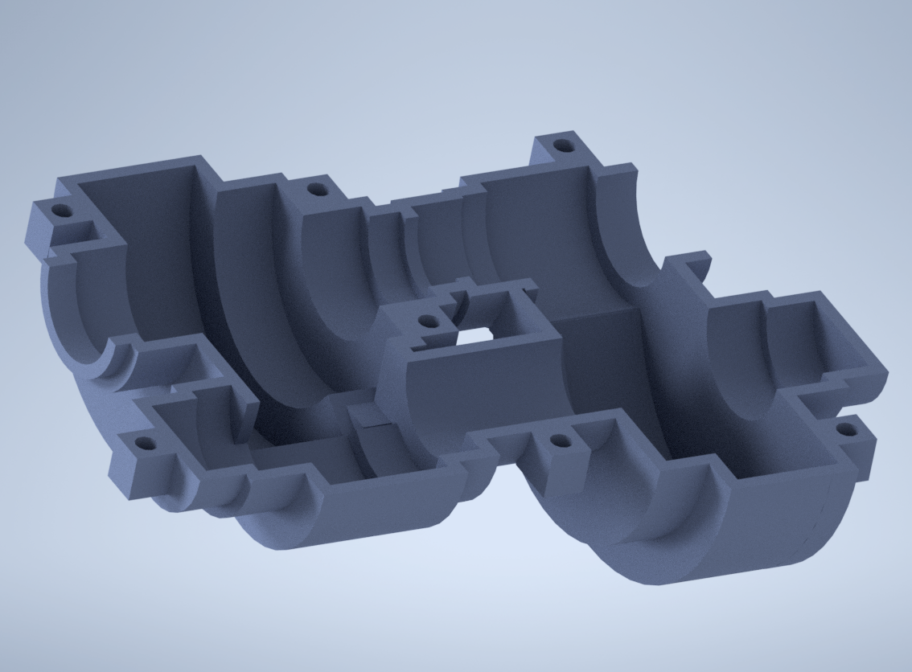
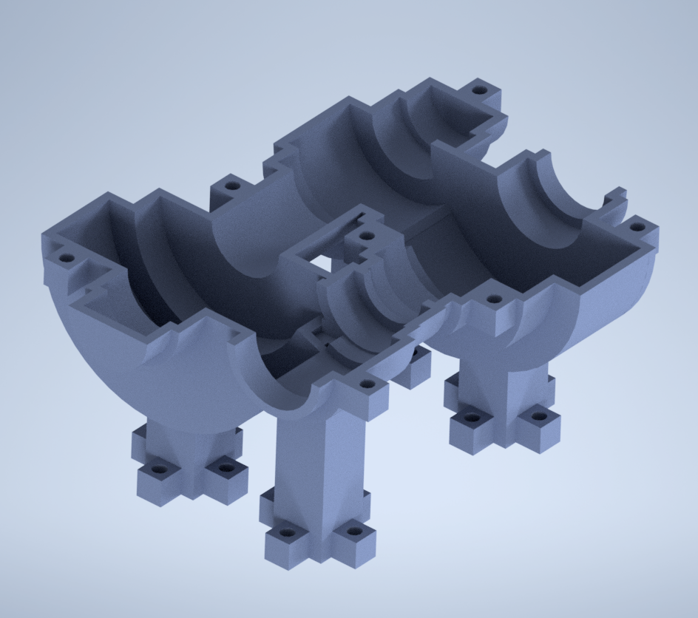
Figure 5: The two separate parts the whole housing consists of.
Main Bottom Casing Part on the left
Top Casing Part on the right

Assembly:
These two parts would be assembled together by screwing M8 bolts through the 7 bolt holes across both parts. The holes for the top casing are not threaded, while the holes for the main bottom casing are threaded, as shown further up close below in Figure 6, as the threads can’t be seen in Figure 5.

Note: The requirements say 4-6 M8 bolts. However, I feel like it is necessary to include an additional bolt in real practice to tightly secure the middle gap together; otherwise, this section would be loose.

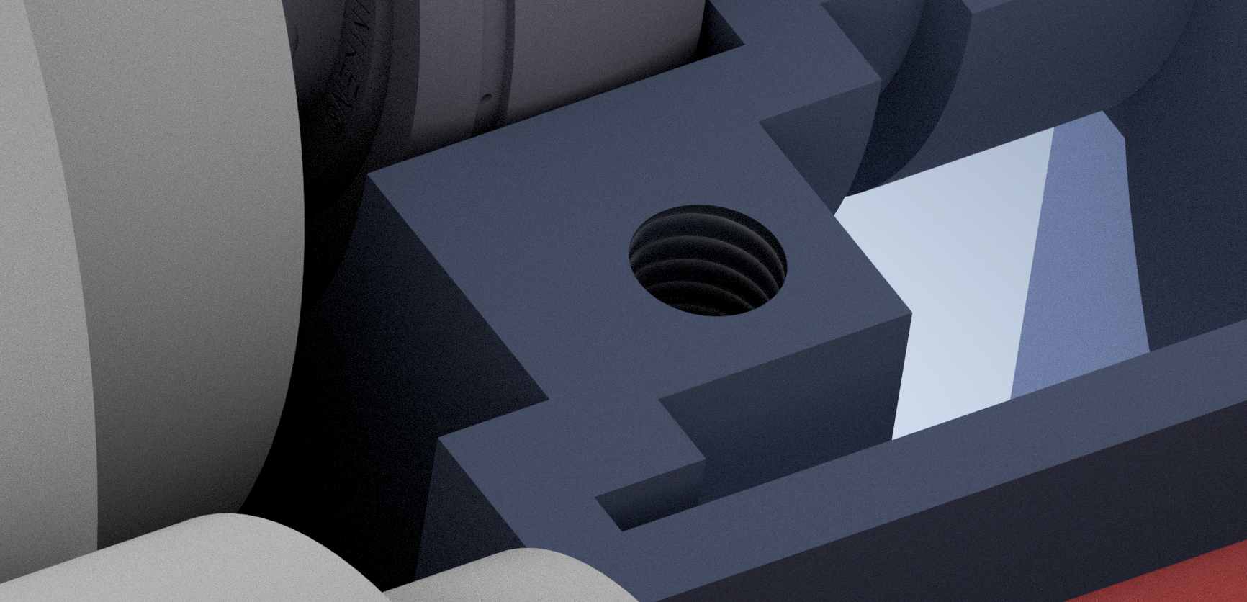
Figure 6: Close-up of a threaded hole for the Main Bottom Casing Part
Main Design Issues and Solution:

Minimising volume to minimise cost:

- Instead of designing a boxy, simple housing casing, I have decided to fully utilise the given requirement of a minimum 10mm interior clearance from rotating components. This means that the edges of the housing would be 10mm from the rotating shafts and gears in all directions all around, leading to the high-degree circular revolving shape of my whole design housing, as shown in the figures above.

- I have also ensured the housing casing thickness is 5mm (the minimum provided) all around to avoid any unnecessary volume.

- For the 4 legs implemented in the main bottom casing part, I have decided to shell the inside of each leg all the way up towards the circular parts in order to additionally effectively reduce volume.

Engineering Drawings:

Provided below are:
3 sheets of dimensional drawings for the main bottom casing
2 sheets of dimensional drawings for the top casing
1 sheet of parts list and volume table
